Get a superdarn potential pattern/flow speed…

Go to the VirginiaTech SuperDARN site:

http://vt.superdarn.org/tiki-index.php

Scroll down the left side until you find the entry called:

Map Potential Data click on this.

Should get a page that looks like:

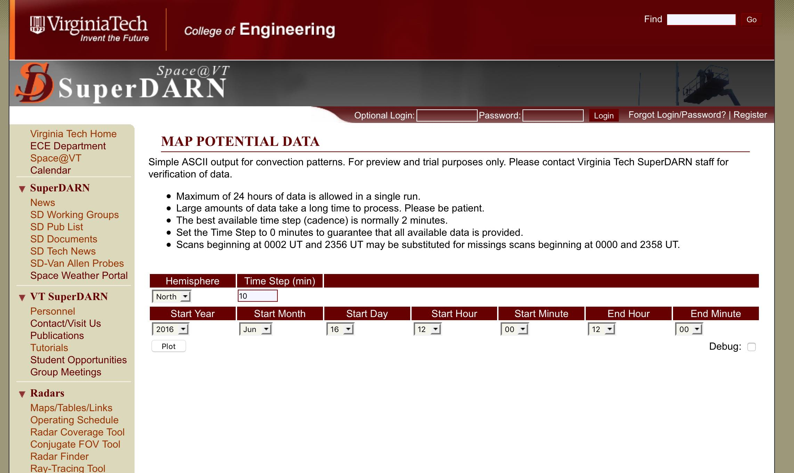

Put in the start date and time, and the end time. Don’t worry about details of plot, what you want is the ascii file. Then click on Plot.

Should get a result like this:

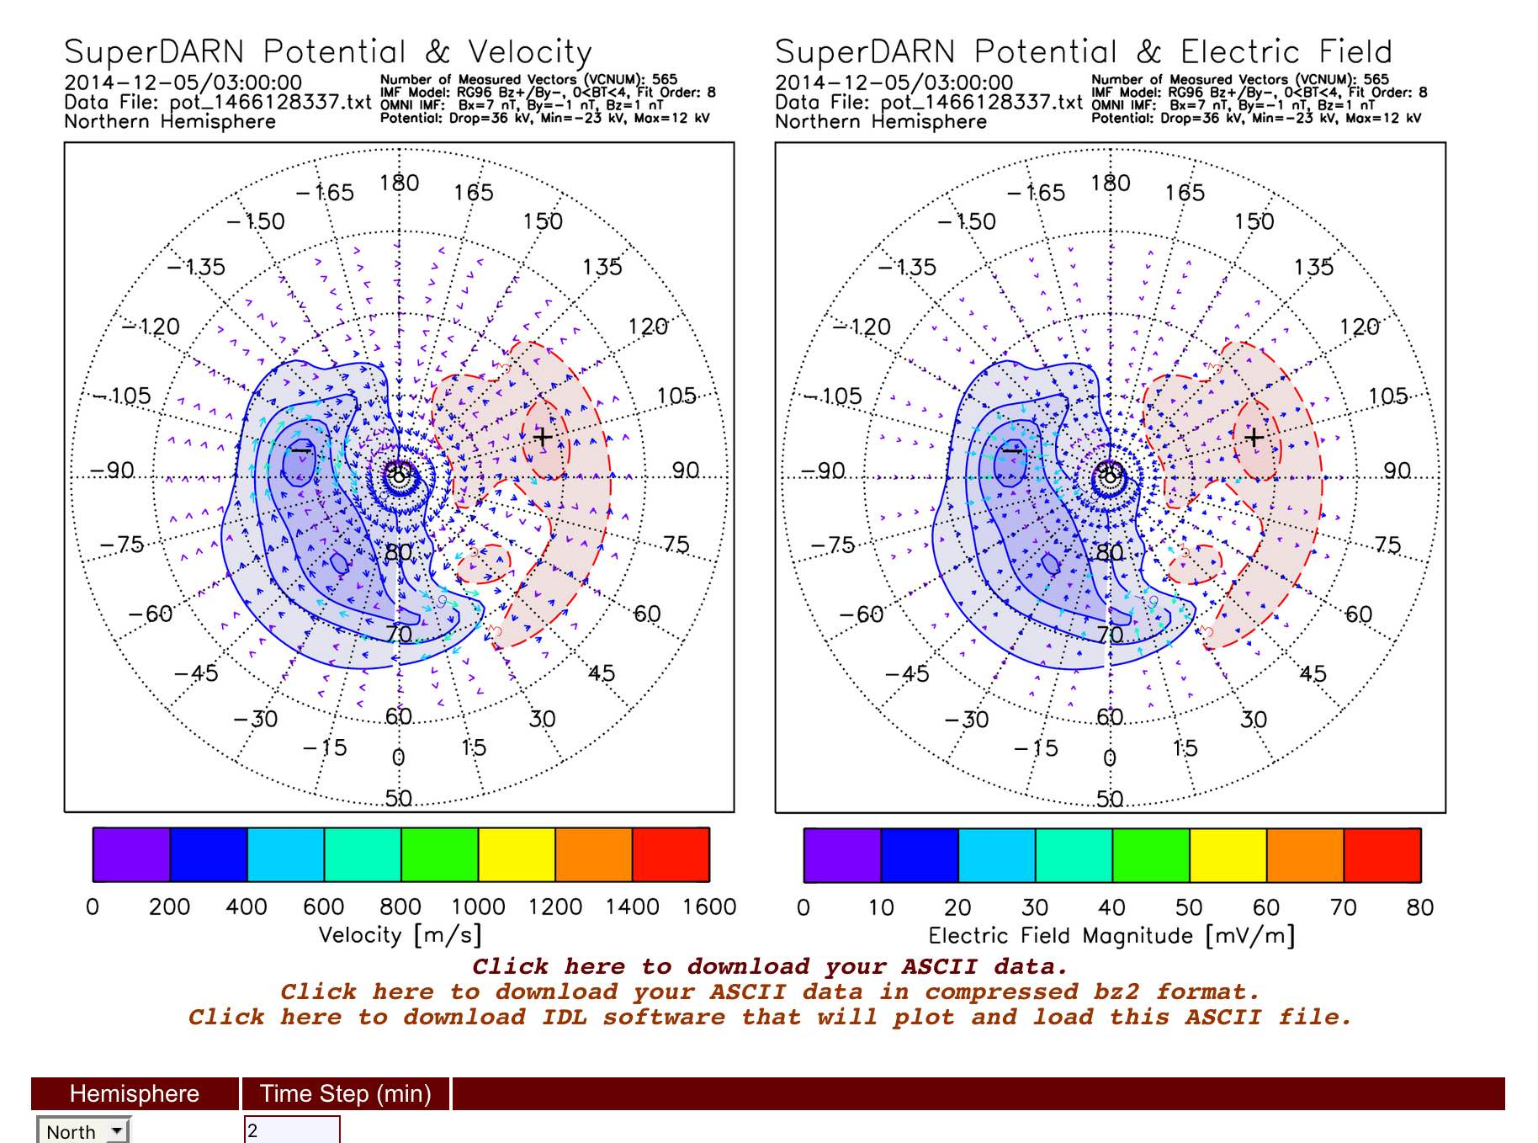

Click on the “Click here to download your ASCII data in compressed bz2 format.” This file will be on the order of 2 to 10 MB. Uncompressed is on the order of 30 to 100 MB.

Save this file in a carefully named folder for the date since the filename has no information of the date of the data you are working with.

You can download the IDL software, but I have uploaded it to an FTP site here.

